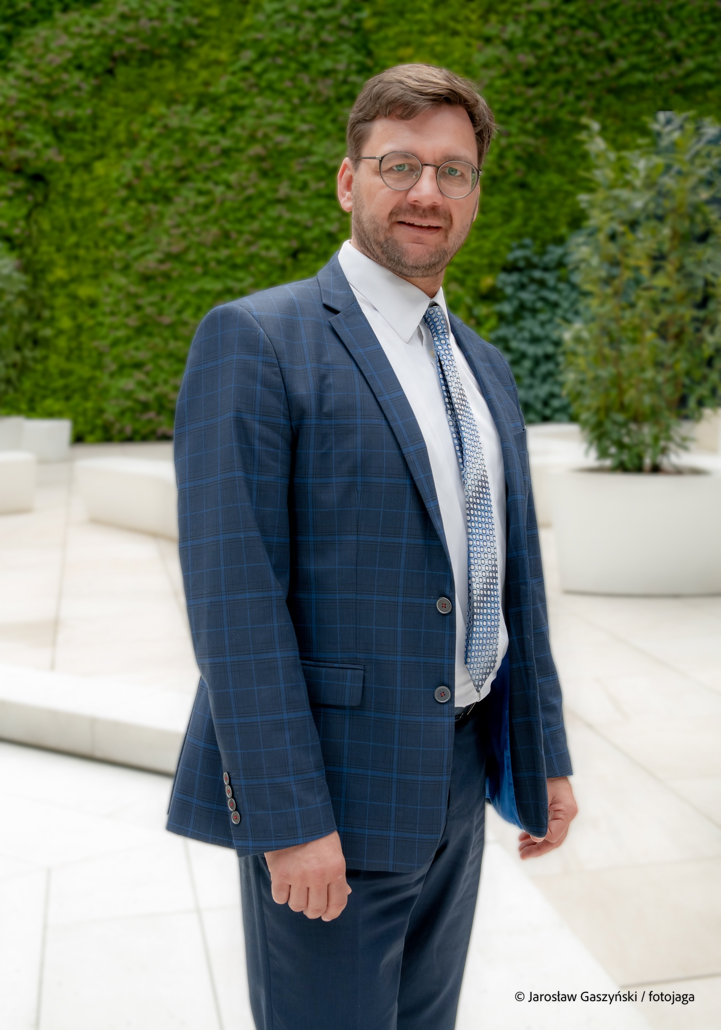

Michael Glueck is the President of the Management Board at SAIL International School in Szczecin, Poland. Previously, he taught German Regional Studies at the University of Szczecin and headed the joint Urban Management Center Poland of the Dutch IHS (now part of Erasmus University Rotterdam) and the Academy of European Integration in Szczecin. Alongside education, he has worked for a total of thirty years in international public service and as an entrepreneur in the international HR sector. He graduated in Political Science and studied Business Administration in Germany and Singapore.